**School of Science, Computing, and Engineering Technologies**

**COS10025**

**Technology in an Indigenous Context Project**

**Final project reflection report**

Project Title: INTEGRATED SOLAR SYSTEM IN IMANGARA COMMUNITY

Student Name: Justin Nguyen

Student ID: 104309099

Date: 23/05/2024

**Acknowledgment of Country**

I respectfully acknowledge the Wurundjeri People of the Kulin Nation, who are the Traditional Owners of the land on which Swinburne's Australian campuses are located in Melbourne's east and outer east. I pay our respects to their past, present, and emerging Elders.

I also respectfully acknowledge Swinburne's Aboriginal and Torres Strait Islander staff, students, alums, partners, and visitors.

I also acknowledge and respect the Traditional Owners of lands across Australia, their Elders, Ancestors, cultures, and heritage, and recognize the continuing sovereignties of all Aboriginal and Torres Strait Islander Nations.

**Declaration**

I declare that this report is my work. I have not copied from any other student's work or from any other source except where due acknowledgment is made explicitly in the text, nor has any part of this submission been written for me by another person.

**Signature: Minh**

## Part A

### Introduction (Project Description)

Our project for this unit aims to address the struggle with high electricity bills faced by the remote Indigenous Township of Imangara.

Located in the Southeast of Tennant Creek in the Northern Territory of Australia, the Township has confronted significant economic challenges, especially the problem of high electricity bills due to high living costs, low income (N.T. Government, 2024), and high unemployment rate that put the financial burden on residents (ABS, 2021).

As such, reducing electricity prices is essential to reducing financial burdens, handling socioeconomic issues, and helping the community allocate resources to more urgent issues and projects, which help boost their economy.

Our project focuses on harnessing clean energy to power an innovative solar system. We want to create a versatile and environmentally friendly system that decreases the community's grid reliance by integrating renewable energy technologies like solar energy. If successful, this project could be scaled up to help other communities with related issues.

### Recommended option to proceed

After several discussions, we have chosen the project's design idea: the solar panel system to harness energy. This design idea provides many benefits, impacts, and opportunities for present and future use.

The components of this design idea include hardware parts like solar panels (collecting solar energy), batteries (storing energy), an inverter (converting to electricity for the household), and an energy management system (monitoring usage). The idea's primary approach to preventing the increase in electricity bills is to absorb sunlight, convert it into energy, and store it in the battery storage system.

The integrated solar power system holds immense potential to revolutionize the *power supply* for the Imangara community, offering a sustainable, long-term solution that reduces their reliance on the grid and non-renewable energy sources like fossil fuels. This shift towards energy security could alleviate the community's financial burden and open up new economic avenues, such as tourism, potentially skyrocketing the community's income. Moreover, given the abundance of sunlight in the Northern Territory in Australia, this project could provide a lasting, environmentally friendly solution for the community, significantly reducing toxic chemical emissions and mitigating adverse effects on the local ecology.

Our project also promises significant improvements in the lives of the Imangara community residents. Primarily, it enhances public health and well-being by reducing the carbon footprint and providing clean air for the community. Additionally, the project could create employment opportunities for the locals in installation, operation, and maintenance, thereby bolstering the economy, preventing poverty, and paving the way for a brighter future for the community.

However, it is essential to acknowledge that every project has its challenges. One of the potential hurdles is the high initial investment required to install the system. Even though solar technology has decreased, a low budget is still an obstacle to buying the required tools and equipment, such as solar panels, battery storage systems, monitoring tools, and software. Moreover, maintenance and repair of the system may require professional staff. Even if the local staff are trained, it would require a long time for the locals to adapt to the work. In case of an accident or an emergency, this solar system could be shut down for an extended period, affecting the daily life of local people. These challenges, while significant, are not insurmountable, and our team is unwavering in our commitment to finding solutions that work for the Imangara community.

In conclusion, this design offers various benefits and impacts for the locals in Imangara Township. It provides a long-term power solution, improves well-being, promotes public awareness about environmental conservation, and provides room for economic and educational boosts. However, high initial investment and high skill requirements are potential constraints during operation and maintenance.

### Part B: Project reflection

### Group Work Reflection

1. Describe the group work strategies/processes that worked for your team.

Many successful groupwork strategies have been used in our team:

* Our team prioritized open and straightforward communication through weekly online meetings, ensuring everyone agreed with the project's objective of tackling the problem in the Imangara community.
* Collaborative decision-making facilitated our ability to use various skills and make educated decisions. Tasks were delegated based on each individual's strengths, and progress updates were made to resolve problems. For example, I am responsible for searching for essential information for the project, while Daniel’s task is to handle online meetings and take meeting notes.

1. Describe the group work strategies/processes that did not work for your team.

While several effective strategies have been utilized, we did meet some challenges.

* Punctuality: When a team member arrives late or misses the workshops, he may need help understanding some parts of the project or even miss the exercises. For example, Daniel did not arrive for the week six workshop, so he missed the worksheet.
* Team disagreement: Some parts of a design idea needed to be improved or modified, but other team members still wanted to keep it the same. For example, Viet wanted my design idea to be more specific regarding technologies, but I thought the idea worked fine. In the end, I agreed to change the idea based on recommendations from my tutor.

1. Describe what could be improved next time you work in a group. It should be from your perspective, e.g., "not working with person X" is not something **you** can change.

In the future*,* I would develop effective strategies and avoid the same mistakes I have made during this group project:

* Communicating frequently through social media platforms and express your thoughts freely.
* We are identifying challenges, suggesting solutions, and being more active in solving problems.
* Managing time effectively by setting clear deadlines and allocating time to be able to deal with unexpected challenges
* You seek feedback from tutors/facilitators and ask questions about problems or parts of the tasks that you may want to clarify.

1. Describe an event/action in your team (i.e., not just from you) that you think was outstanding for each of the:
   1. Team organisation

Everyone agreed on project management together, allowing us to track our deadlines. For example, Pawarit is responsible for asking tutors for guidance, while Siradanai and Viet will manage each member's tasks and ensure they are correctly submitted.

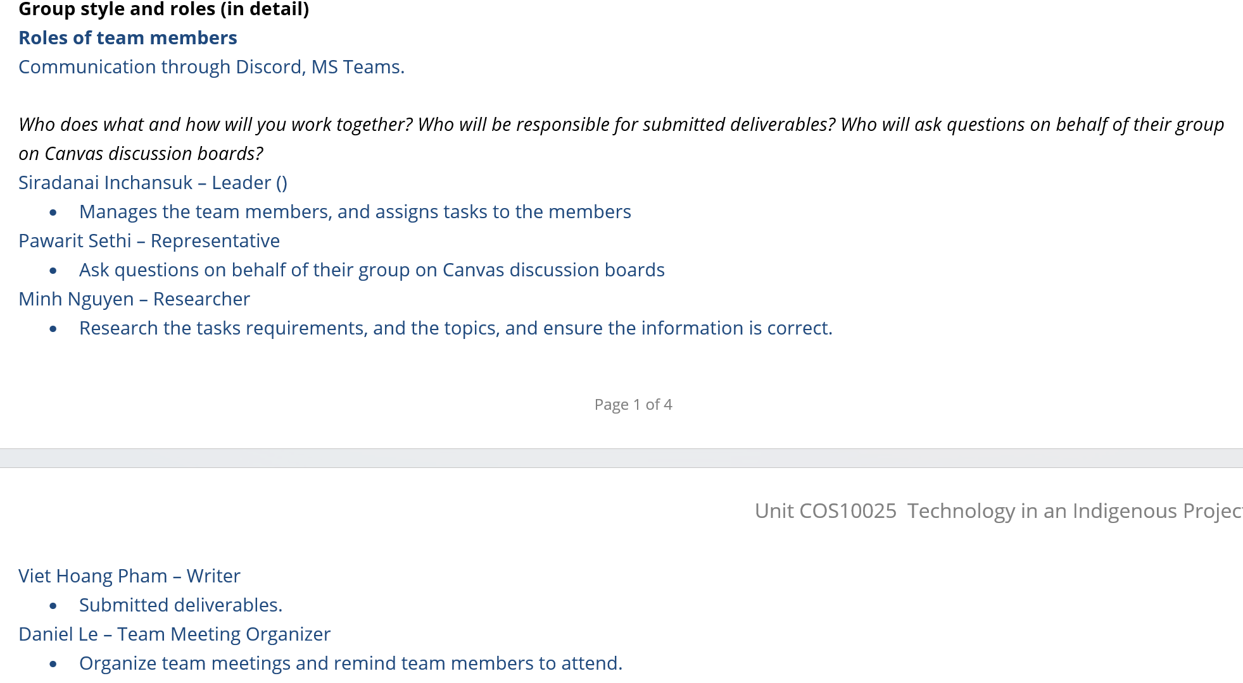

*Team agreement on group roles*

* 1. Meetings

In the workshops, we discussed what to do in the following weeks, what we had done well, and what we needed to improve.

In the online meetings, we discussed the weekly submission. We consulted with the tutor, carefully reading the feedback from our tutor regarding previous submissions to avoid the same mistakes in the next task.

*Team agreement on meetings*

* 1. Delivery of the project design ideas

In the first period, we discussed the community, its problems, and the technologies we should use for the project. After that, we chose five design ideas that would suit the community's problem. During weeks 3 and 4, we researched the community's problem through the websites of Indigenous communities and governments like ABS.

* 1. Delivery of the Innovation concept

All members have written a part of the report, including the introduction of the community and their problem, details of the design ideas about definitions, devices, technologies, benefits, impacts, and constraints with references.

* 1. Delivery of the final presentation

Each member took responsibility for specific parts while making the slides and class presentation. However, many things still needed to be corrected, such as the slides' format and the team's performance in the last presentation. For example, Daniel volunteered to present the introduction and the justification parts while other members presented their design ideas. After the presentation, each member was given a question to be answered based on the design justification.

### Individual Work Reflection

* Project tasks
  + Describe your tasks in the group project in each phase of the project (add evidence)
    - Phase 1 – Identifying the Township and the team problem

I found many different townships and their problems, and after several discussions, our team decided to choose Imangara as the community for the project. After that, I found an article about the problem of high electricity costs on the Northern Territory community's website (N.T. Government, 2024).

* + - Phase 2 – Develop design ideas, Use design criteria to make standard design ideas, and analyze the benefits and impacts of each design idea

*Battery Storage System as a reference*

I have considered using renewable energy and a battery storage system to store energy. Later, the design idea we chose as the best used this idea as a reference.

* + - Phase 3 – Design justification

*Design justification scores*

I evaluated and justified all five design ideas. After receiving the results in week 7, I added more justification based on our tutor's feedback.

* + - Phase 4 – Design Presentation

I presented my design idea and contributed to the design justification at the end of the presentation.

* Contributions to the group
  + Describe how your efforts contributed to the whole group

I contributed to developing the project's design idea and worked on the best format for the report and the slides for the presentation. I also searched for information to support the design ideas and complete the written parts of the project.

* + Describe how you were involved in the teamwork environment

As a researcher of my team, I played a role in finding necessary information to strengthen our design idea, working on written parts of the project, and asking for feedback from the tutor to ensure our team's work met the unit's requirements.

* Conclusion and recommendation
  + Conclude your achievement with a culturally suitable solution (you can pick either 1 or 2 design ideas that suit well)

The choice of using P.V. panels for energy collection in Imangara Township has been an outstanding achievement because we have addressed the problem of high electricity costs while respecting the community's culture. The installation of P.V. panels contributes to the community's long-term development in terms of economy and education.

* + Recommend how you could further improve your design ideas within a team environment.

To better improve the design idea in the future, I could:

* Learning more about high-end technologies that could be applied to the project. Seeking sponsorship from different companies and organizations to scale the project to other communities with related problems.
* We are searching for information about similar projects to refer to our project and surveying the actual situation in Imangara Township to ensure that the project suits the community's needs.

## Part C: Unit Learning Outcomes (ULOs)

1. Locate Indigenous knowledge systems and consider how they story the history of technology, science, and engineering. (add evidences)
   1. Understanding and exploring Indigenous knowledge systems

When implementing the project, we would research the locals to understand their traditional values better and their current problems related to electricity issues. We want to ensure that our project respects the Indigenous knowledge systems and meets the community's needs (House, W, 2022, December 2).

* 1. Ensure undertaking the project by locating Indigenous knowledge systems (Technologies)

By considering Indigenous knowledge systems, we could boost the community's pride in its values, foster cultural values, and broaden its access to contemporary technologies and other parts of the economy.

1. Explain the importance of and find opportunities to converge Western knowledge systems with Indigenous knowledge systems respectfully. (add evidences)
   1. Brainstorming the importance of Indigenous knowledge systems

Our findings proved that they have essential knowledge about their surrounding environments. For instance, Imangara has a proud history of managing its land.

* 1. Understanding the Indigenous knowledge systems and uniting with Western knowledge systems

We can lessen the distance between traditional and modern knowledge systems and use their strengths by delving into their meaningful functions and properties. It will integrate their understanding and best practices, resulting in appropriate creative solutions (House, W, 2022, December 2).

* 1. Understanding and applying the correct use of terminologies

When learning about Indigenous knowledge systems, we must honor and respect Indigenous languages to guarantee that their ideas and perspectives are accurately reflected and prove we have no intention of discriminating or belittling them (Joseph, B., 2024, April 1).

1. Apply relevant knowledge of emerging technologies to a project within an Indigenous context, considering and acknowledging Indigenous histories, worldviews, standpoints, and cultures. (add evidence from weekly workshop team activities, weekly seminar reflections, and assessments)
   1. Analyzing the challenges, needs, and services for the remote Indigenous community

When we conducted the in-depth study and held in-depth talks, we always considered the Imangara community's unique cultural background. Then, we researched the community's struggle with affording their electricity bills and decided that modern technologies could be a key to the issue (N.T. Government, 2024).

* 1. Explore user access, affordability, and appropriateness of the design ideas.

Through our weekly lectures and workshops, our team critically assessed the viability and practicality of implementing our design idea concerning Indigenous values. We considered the community’s access, the appropriateness of cost and culture, and the level of technical knowledge and skills for long-term use.

1. Function as an influential team member using project management tools and demonstrating professionalism and ethical behavior. (add evidences)
   1. Attended team meetings, facilitator meetings, and workshops

I attended all meetings, workshops, and lectures. I listen carefully to the lectures' content and our tutor's guidance.

* 1. Assisted in planning for the team

I was responsible for developing the team's design ideas and double-checking their work before submitting it on Canvas.

* 1. Delivered work on time for the team

I always finished my work ahead of deadlines, which was of high quality and with minor mistakes.

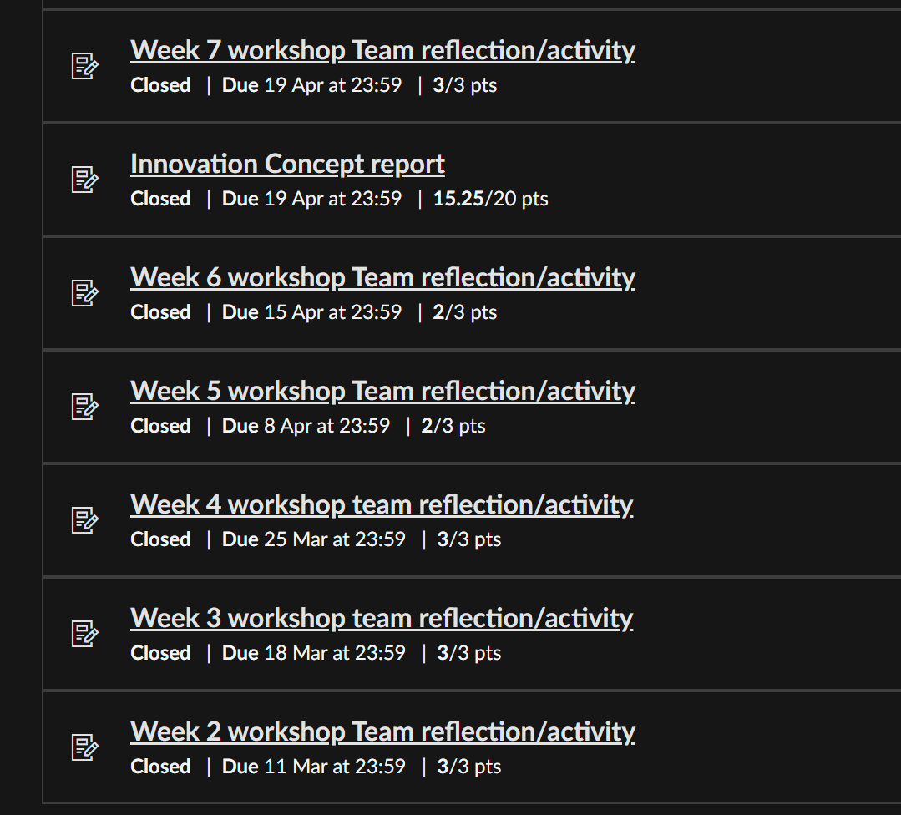

*Work delivery*

1. Communicate with teams and stakeholders using appropriate verbal, written, and technological approaches. (add evidences)
   1. Contributed to team meetings

I attended all my team's meetings and gave some advice on improving design ideas by applying technologies and integrating renewable energy sources.

* 1. Engaged in facilitator meetings

I participated in the facilitator meetings and listened carefully to our tutor's feedback.

* 1. Proficient in verbal communication, both presentations and conversation

I could give clear presentations to convey my ideas and my written work. I always prepare small notes for what I should say or ask in the workshops.

* 1. Proficient in written communication, both reports and online interaction

I produced organized, high-end reports that conveyed my findings, the design ideas, and the project results. I always use grammar-checking tools like Grammarly or paraphrasing tools like Quillbot to ensure my work is not a copy of other work and that my work is referred to properly with APA references.

*Use of Grammarly for checking the work*

* 1. Made use of other tools (e.g., online brainstorming tools) to interact with others

I applied various online tools like Microsoft Copilot into practice to find articles and research related to the community and its problems. I also made use of Grammarly-checking and paraphrasing tools, as mentioned above. Microsoft Teams is utilized for online meetings, and I took notes using Google Documents.

*Use of Copilot for research*

1. Appreciate emerging technologies in a local, global, and sustainable context (add evidence)
   1. Considered a culturally appropriate design idea

Our group's chosen idea ensured that it met the cultural beliefs of Imangara township by respecting their knowledge about their culture while fostering their desire for ownership and integration with modern technologies within the community to help them tackle the problem (The University of Sydney, 2021, December 16).

* 1. Explored sustainable livelihoods through the design idea

The possible benefits and impacts of the idea to the Imangara people were thoroughly analyzed and considered. The assessment is based on the benefits and economic opportunities it may bring to the community's well-being. The solution is designed to tackle the issues and encourage long-term sustainability. (The University of Sydney, 2021, December 16).

### Word Count: 2859

### References

Acknowledgment of Country. (n.d.). <https://www.swinburne.edu.au/about/strategy-initiatives/moondani-toombadool-centre/acknowledgement>

Northern Territory Government. (2024, March 15). BushTel – Remote Communities of the N.T. <https://bushtel.nt.gov.au/profile/250>

ABS. (2021). Imangara. 2021 Imangara, Census Aboriginal and Torres Strait Islander people QuickStats | Australian Bureau of Statistics. <https://www.abs.gov.au/census/find-census-data/quickstats/2021/ILOC70700303>

House, W. (2022, December 2). What is “Indigenous Knowledge” And Why Does It Matter? Integrating Ancestral Wisdom and Approaches into Federal Decision-Making. The White House. <https://www.whitehouse.gov/ostp/news-updates/2022/12/02/what-is-indigenous-knowledge-and-why-does-it-matter-integrating-ancestral-wisdom-and-approaches-into-federal-decision-making/>

Joseph, B. (2024, April 1). Indigenous Peoples Terminology: Guidelines for Usage. <https://www.ictinc.ca/blog/indigenous-peoples-terminology-guidelines-for-usage>

Renewable energy and empowering Indigenous communities. (2021, December 16). The University of Sydney. <https://www.sydney.edu.au/sydney-environment-institute/news/2021/12/16/renewable-energy-and-empowering-indigenous-communities.html>